**Evidence of *Ostrea lurida* (Carpenter 1864) population structure in Puget Sound, WA**

J. Emerson Heare1, Brady Blake2, Jonathan P. Davis3, Brent Vadopalas1, Steven B. Roberts1

School of Aquatic and Fishery Sciences, University of Washington1

Washington Department of Fish and Wildlife2

Puget Sound Restoration Fund3

Seattle, Washington

United States of America

Corresponding Author:

Steven B. Roberts

1122 Boat St.

Seattle, WA 98105

sr320@uw.edu

**Abstract**

For long term persistence of restored species, it is important to consider genetic population structure. Traits that hold adaptive advantage such as reproductive timing and stress resilience may differ among locales within a species. Using three established populations of *Ostrea lurida* within Puget Sound Washington, a reciprocal transplant experiment and monitoring survival, growth, reproduction was performed. It was found performance differed for each population at each of these three metrics. *Ostrea lurida* from Dabob Bay had higher survival at all sites but lower reproductive activity and growth. Whereas those from Oyster Bay had greater reproductive activity at all sites but moderate growth and survival. Populations from Fidalgo Bay exhibited greater growth in the southern most site but not at home and had limited reproductive activity and survival.

Keywords: *Ostrea lurida*, Restoration, Olympia Oyster Growth, Reproduction, Mortality, Adaptation

**1. Introduction**

Restoration of native species has been of growing concern in the face of habitat degradation, loss of ecosystem services, and global climate change (Anderson, 1995; Lotze et al., 2011). Faced with mounting challenges, resource managers and conservation groups turn to transplantation of viable animals into habitats to supplement dwindling populations and encourage self-sustained persistence.

The Olympia oyster, *Ostrea lurida* (Carpenter, 1864), the only oyster native to the west coast of North America, exists in a wide variety of habitats within its range from Baja California, Mexico to British Columbia, Canada (Couch and Hassler, 1989). *Ostrea lurida* is moderately euryhaline (Baker, 1995) and lives in the lower intertidal, from 1 m above sea level to 10 m below (Baker, 1995), experiencing temperatures ranging from an average minimum temperature of 5 ̊C to 20 ̊C in South Puget Sound (Couch and Hassler, 1989) They cannot survive freezing (0 ̊C) (Baker, 1995) or temperatures above 39 ̊C (Wasson et al., 2014). Even at the scale of Washington state’s Puget Sound, oceanographic features create diverse habitats in which remnant populations persist. *Ostrea lurida* are protandric hermaphordites (Baker, 1995), spawning first as male followed by a male-female stage cycling. Studies by Coe (1932) and Hopkins (1936) assumed that reproductive activity begins in the second year of life. Hopkins (1936) observed in South Puget Sound that at maximum 10-15% of *O. lurida* populations are brooding at any given time during spawning season. Peak larval setting, roughly correlating to peak spawning, occurs twice annually with South Puget Sound (Hopkins, 1936). There is no maximum age known for *O. lurida* but monitored control populations experienced a 34% mortality annually (Couch and Hassler, 1989). Since the mid 1800’s, *O. lurida* populations throughout the range have significantly declined due to historical overharvest, industrial pollution, and sedimentation caused by logging and mining operations (Baker, 1995; White et al., 2009; Blake and Bradbury, 2012). This oyster has been subject to substantial restoration efforts (McGraw, 2009) but despite the widely different environmental conditions which *O. lurida* persists, information on adaptive stock structure is lacking (Camara and Vadopalas 2009). To better predict the success of *O. lurida* supplementation efforts within Puget Sound, more extensive research needs to be performed to determine whether local populations vary in performance metrics that may be indicators of local adaptation.

Among methods for testing for local adaptation, reciprocal transplant experiments are considered robust (Sanford and Kelly, 2011) for investigating key metrics of fitness. These experiments involve using parent populations from environmentally diverse locales to produce offspring that are placed reciprocally in their home and foreign environments. Population differences in key metrics for fitness can indicate an adaptive advantage (Burford et al., 2014). Three metrics that are fitness correlates and can be indicative for persistence are survival, reproduction, and growth. Survival, being the most obvious, can determine whether conditions within a site are capable of sustaining supplemental populations. Reproduction determines a population’s ability to become self-sustaining by producing offspring for self-recruitment. Growth, while not a direct fitness correlate, can represent a myriad of factors affecting oyster size and development. By measuring how each of these metrics change in each population at each site, we will be better able to define population related traits and identify populations with traits more likely to be successful in supplementation efforts.

The main objective of this study was to determine whether *O. lurida* populations from geographically diverse areas of Puget Sound exhibit population-level differences in survival, reproduction, and growth in different environments.

**2. Material and Methods**

*2.1 Broodstock Conditioning and Outplanting*

Adult oysters (n=600) were collected from three locations in Puget Sound (Fidalgo, Dabob, and Oyster Bay, Fig. 1) during November and December 2012. Gametogenesis and maturation occurred after being held for 5 months in common conditions in Port Gamble, Washington. To ensure genetic diversity, each population was subsequently spawned in 24 groups of 20-25 oysters from each location in June 2013. Larvae produced from each population were reared in 4 replicate screened silos, settled on microcultch and fed ad libitum until attaining the minimum outplant size (SL = 5 mm).

In August 2013, 480 oysters (5-10 mm) from each population were planted at Fidalgo, Oyster, Dabob, and Clam Bays (Fig. 1)**.** At each site, oysters from each population were placed into four 0.61 X 0.61 m growout trays. In each tray, oysters (120) were equally distributed in four 10x7.5cm mesh (1475 micron) bags containing 30 oysters each. Trays were anchored into substrate using rebar stakes. In late autumn, trays at Fidalgo, Oyster, and Clam Bays were subsequently suspended from floating structures to reduce exposure to extreme temperatures during tidal exchanges. Trays remained anchored to the substrate in Dabob Bay as no suitable floating structure was available. At each site, HOBOlogger temperature sensors (OnSet, USA) were deployed.

*2.2 Site Monitoring*

*2.2.1 Temperature*

Data from temperature loggers were collected at regular intervals and used to calculate minimum and maximum observed temperature for each day using the R 3.0.3 (R Core Team, 2014, package “plyr” (Wickham, 2014)). The number of days above 20 ̊C and below 5 ̊C was calculated for the duration of the project. Degree days was calculated by adding the cumulative difference between the daily minimum temperature and the 2014 winter average minimum of 8 ̊C to determine the amount of environmental energy needed to produce peak brooding activity. We defined the length of the growing season as being a period when high primary productivity was likely with daily minimum temperatures above 12.5 ̊C. Raw temperature data and analysis procedures used are available (Heare et al., 2014).

*2.2.2 Mortality*

Mortality was determined by direct counts of live and dead oysters at each site visit. Survival was assessed in December 2013, January (Dabob Bay only), February, April (Dabob and Clam Bays only), May (Fidalgo and Oyster Bay only), and June 2014. All trays were examined during winter visits and a single tray was counted each week during June. Differences in mortality within sites were determined through survdiff tests performed in the R 3.0.3 (R Core Team, 2014) with the R package “*survival*” (Therneau, 2014). Raw mortality data and analysis procedures used are available (Heare et al., 2014).

*2.2.3 Growth*

Size was determined using digital images of oysters via ImageJ analysis (Rasband, 2010). Images used were taken in August 2013 (All sites), April (Dabob Bay), September (Oyster Bay), and October 2014 (Fidalgo and Clam Bays). For each image a reference was measured along with all oysters. For all oysters a linear measurement was made at the longest distance from umbo to valve margin. Descriptive statistics were produced by the package “pastecs” (Grosjean and Ibanez, 2014). Size distributions were tested for normality using the Shapiro-Wilkes test ( “stats” package, R Core Team, 2014). Growth was compared using Kruskal-Wallis assuming non-normal distribution (“stats” package, R Core Team, 2014). Pairwise comparisons were performed using the Nemenyi PostHoc test using Tukey assumptions (R package “PMCMR”, Pohlert, 2014). Raw size data and analysis procedures used are available (Heare et al., 2014).

*2.2.4 Reproductive Activity*

To assess reproductive activity the number of brooding oysters were determined on weekly basis over three months (May 14th - August 15th, 2014) for a total of 15 timepoint observations for each site. Individual trays of oysters were anesthetized, and each oyster was visually inspected for presence of broods in the mantle chamber. Specifically, trays were removed from water and exposed to air for 45 minutes then immersed in 0.3M magnesium sulfate (heptahydrate sulfate mineral epsomite MgSO4·7H2O) (Epsom salt) dissolved in a 50/50 mix freshwater/sea water for 45 minutes. Each brooding female was record for the day and then measured using calipers. The date of maximum brood activity was consider to be the date with the highest proportion of brooding females observed. Following Hopkins (1936) observation of the daily minimum temperature spawning threshold for *O. lurida* of 12.5 ̊C, we counted the number of days from the first date which reached this threshold to the date of the first brooding female observed and the maximum percentage of brooding females observed. The proportion of brooding adults per site per visit was arcsine transformed and analyzed via ANOVA. Significant differences among sites, populations, and population by site interaction were determined using Tukey’s test (TukeyHSD ‘base’ package, R 3.0.3 (R Core Team, 2014)) test to compare differences across sites, populations, and population by site. Sizes at brooding were likewise compared via ANOVA and TukeyHSD. (R 3.0.3 (R Core Team, 2014) ‘base’ package). Raw brood data and analysis procedures used are available (Heare et al., 2014).

## 3. Results

*3.1 Site Characteristics*

Oyster Bay had the highest daily minimum temperature (18.43 ̊C) (Fig. 2) in August 2014 while Dabob Bay had the lowest daily minimum temperature (-3.32 ̊C) during February 2014 (Fig. 2). The Dabob Bay site experienced the highest amount of temperature variability due to the intertidal placement of samples and the extreme cold weather during low tide events (Fig. 2&3). The Oyster Bay site experienced warm daily temperature from mid-May throughout the summer. From June to August 2014 this site experienced the warmest daily minimum and maximum temperature as compared to all other sites (Fig 2 & 3). The growing seasons for Oyster, Fidalgo, and Clam Bays were 129, 72, and 69 days with daily minimum temperatures above 12.5 ̊C respectively.

*3.2 Survival*

Differences in mortality were observed based on broodstock location of origin at three of the four sites. Dabob Bay oysters had more individuals survive by the end of the study period at Dabob, Oyster, and Clam Bays (Fig. 4A, 4B, 4C) than the other populations. At Oyster Bay, the native population performed the worse with 37.0% (+/-2.3%) survival (Χ2=76.3, df=2, P=0) (Fig. 4A). Limited mortality was observed at Clam Bay where at least 80% (Χ2=13.7, df=2, P=0.00105) of oysters remain after 11 months (July 2014) (Fig 4B).

The Dabob Bay location experienced the highest overall mortality, as such the trial was ended prematurely in April 2014. There was also significant differences in mortality across populations (Χ2=141, df=2, P=0), with the Fidalgo Bay oysters having the lowest survival (21.2% +/- 2.1%) (Fig 4C). At the Fidalgo Bay field site, at least 80% of the oysters from all three cohorts remain after 11 months. No differences in mortalities between populations were observed at Fidalgo Bay (Χ2=2.6, df=2, P=0.247) (Fig 4D) .

*3.3 Growth*

Mean oyster size at outplant was 11.36 +/-3.15 mm. At Oyster Bay, Fidalgo Bay oysters grew to a larger size 35.8 +/-6.4 mm than Dabob and Oyster Bay oysters (Fig 5). At both Fidalgo and Clam Bays, oysters from Dabob Bay were smaller than other population at the end of the experiment (Fig. 6 and 7). Average sizes of all populations at all sites can be seen in Table 1.

*3.4 Brooding Females*

The numbers of brooding females varied between populations and between sites. The Oyster Bay population produced the significantly more brooding females at Oyster and Fidalgo Bays and the highest number of brooding females at Clam Bay. Sites varied significantly as well with the largest number of brooding females present at Oyster Bay (Fig. 8) and the least amount of brooding females at Clam Bay (Fig. 10). Oyster Bay reached the spawning temperature threshold on May 14th and the first brooding female was discovered 15 days later on May 29th (Fig. 8). Oyster Bay reached maximum percentage of brooding females observed by June 19th, 36 days post threshold temperature or 308 degree days from the 2014 winter average temperature (8 ̊C). Dabob and Fidalgo Bays’ populations reached maximum percentage brooding females observed on July 10th (Fig. 8), 57 days post threshold temperature or 453 degree days. Ambient water temperatures in Oyster Bay rose steadily from late winter reaching the spawning threshold and continuing to increase to the summer maximum of 18.43 ̊C. At Fidalgo Bay, spawning temperature threshold was met on May 14th and the first brooding female was discovered on June 6th (Fig. 9), 23 days post temperature threshold. Oyster Bay population reached maximum percentage brooding females observed by July 11th at Fidalgo Bay, 58 days post temperature threshold or 354 degree days. Fidalgo and Dabob Bays’ populations did not reach maximum percentage brooding females observed until August 8th (Fig. 9), 87 days post temperature threshold or 513 degree days. Fidalgo Bay had a slower, less steady temperature increase from throughout the spring season with ambient water temperatures reaching 12.5 ̊C around mid-May but then dipping into the 10-11 ̊C range until early June and remained continuously above the threshold for the remainder of the summer. Clam Bay reached the temperature threshold on June 8th and brooding females were found June 18th from the Oyster Bay population (Fig. 10), 10 days post threshold. Due to the low number of brooding females we decided not to calculate degree days for Clam Bay. Temperatures in Clam Bay reached spawn threshold in early June but varied above and below this temperature for several days at a time throughout most of summer. The average and observed minimum size at brooding, 19.1+/-3.7 mm and 15 mm respectively, was observed at Clam Bay from the Dabob Bay population.

**4. Discussion**

Our primary objective for this study was to evaluate population performance in Puget Sound Washington. The reciprocal transplant of Olympia oysters at distinct Puget Sound Washington locations yielded important new information on basic life history characteristics, including maturation as female in the first year of life, and first year average fecundity. Differential performance of populations in diverse environments suggest the existence of local adaptation in Olympia oyster populations.

*4.1* Ostrea lurida *Life History*

*4.1.1 Mortality*

Temperature appears to be a likely factor affecting mortality in Olympia oysters. This observation is consistent with the review from Couch and Hassler (1989); these authors described the average temperature range in the Puget Sound experienced by *O. lurida* as 5 ̊C to 20 ̊C. In the present study, populations growing at sites with more days that exceeded this range exhibited increased mortality.

The overall high mortality observed at Dabob Bay is likely attributed to temperature. The Dabob Bay site exceeded the temperature range reported by Couch and Hassler (1989) on 35% of the total days (85 out of 242 days) with two subfreezing events of -0.78 ̊C and -3.3 ̊C in December 2013 and February 2014 respectively. The Oyster Bay site, which also experience significant mortality, had a total of 39 days outside of the 5-20 ̊C range. The majority (34 days) were above the upper limit (20 ̊C) but not near the lethal temperature (LT50) of 39 ̊C reported by Wasson et al., (2014). The Clam Bay site remained within the average temperature range, and had the highest survival of all sites.

Overall, temperature appears to affect mortality, with elevated temperatures more detrimental to survival. Burford et al. (2014) showed that environmental gradients, especially temperature, were most likely responsible for early life mortality at sites with more variation and higher temperatures. The average temperature range proposed by Couch and Hassler (1989) appear accurate, and the data presented here suggests that subfreezing temperatures are more likely to cause winter mortality.

*4.1.2 Growth*

Based on our findings Olympia oysters can attain an average size of 35.8 mm +/-6.4 (SE=0.594, SD=6.401, CI=1.177) during the first year of growth (Table 1) This is in contrast to what Couch and Hassler (1989) reported that *O. lurida* reach 35-45 mm in size in 2-3 years in South Puget Sound. Some individuals attained sizes >45 mm which is similar to largest growth reported in a single year (Couch and Hassler, 1989). Oyster Bay had the largest average size 30.0 +/- 6.6 mm (SE=0.314, SD=6.643, CI=0.616) (Table 1) as well as the warmest temperatures year round which may have induced higher primary productivity than at other sites and provided more energy for growth in each population. Fidalgo Bay had colder temperatures year round but likely experienced enough primary productivity to induce moderate growth in all populations, average size 27.5 +/-5.4 mm (SE=0.160, SD=5.378, CI=0.315) (Table 1). The Oyster Bay site experienced nearly 2 full months, 57 days, more growing season than the Fidalgo Bay site, possibly leading to consistently more available energy for consumption and growth. The Clam Bay site had temperatures similar to that of Fidalgo Bay but may have experienced lower primary productivity and possibly because of such all populations were on average (23.3+/-5.4 mm (SE=0.200, SD=5.374, CI=0.394)) smaller than the same populations at other sites (Table 1). Overall growth in each area may have been influenced by the amount of available energy within the environment for consumption and growth.

*4.1.3 Reproduction*

In this study, *O. lurida* reproduce as females in the first year of growth, at an average minimum size of 19.1+/-3.7 mm. The average size of brooding females was 27.14 +/- 4.46 mm (SE=0.311, SD=4.46, CI=0.613). This result is surprising, given previous research (Hopkins, 1936; Coe, 1931; Couch and Hassler, 1989; Baker, 1995) that describes *O. lurida* as being unable to reproduce as females until at least their second year (Coe, 1931) at sizes of 35 mm or greater (Coe, 1931; Hopkins, 1936; Baker, 1995).

It has been generally accepted that *O. lurida* begin spawning at relatively low temperatures (13 ̊C Coe, 1931; 12.5 ̊C Baker, 1995). Hopkins (1936) suggested that this temperature threshold must occur during high tide, which is related to the daily minimum temperature. We found at all sites brooding only occurred after daily minimum temperatures increased above 12.5 ̊C. At Oyster Bay, temperatures steadily rose from late winter throughout spring and summer. This steady increase allows *O. lurida* to spawn much earlier in the season than at other sites while providing ample primary productivity to sustain larval growth. On the other hand, Fidalgo Bay was slow to stabilize above the 12.5 ̊C mark until late spring which delayed spawning activities in all populations by a few weeks. Spawning regularity at Fidalgo Bay occurred once temperatures remained above 12.5 ̊C. Daily minimum temperatures at Clam Bay were very slow to reach the 12.5 ̊C threshold and consistently dipped below it for all of spring and early summer. For the majority of the sampling period very few brooding oysters were observed at this site which is likely related to the low temperatures and instability around 12.5 ̊C. The degree to which temperature influences oyster metabolism versus primary production requires further investigation.

*4.2 Population Differences*

*4.2.1 Mortality*

Survival differed significantly among populations. At all transplant sites, the population derived from Dabob Bay parents exhibited better survival than the other two populations; this difference was statistically significant at three of the four transplant sites. Observed temperature variability at Dabob Bay may be indicative of historic trends. If so, the increased survival of the Dabob Bay population could be a function of increased stress resilience in response to prevalent temperature extremes. In previous studies on thermal tolerance, it has been shown that species such as Bay scallops, *Argopecten irradians*, (Brun et al., 2008) and Mediterranean mussels, *Mytilus galloprovincialis*, (Dutton and Hofman, 2009) that experience more frequent exposure to temperature extremes produce more heat shock proteins (HSP) and HSP mRNA transcripts when subjected to warmer temperatures than those that do not. This suggests that species that experience more frequent heat stress devote more resources into the production of proteins to stabilize cell functions and maintain homeostasis. In addition, Sørensen et al. (2004) found that many species exhibit heritable heat shock protein production patterns. This may mean that in the Dabob Bay population the higher survival rates observed are a heritable survival trait that comes with increased energetic cost with reduction in growth and reproduction.

*4.2.2 Growth*

At all transplant sites, the population derived from Dabob Bay parents exhibited the least amount of growth. This observation is likely related to the fact this population also had the highest survival. Applebaum et al. (2014) found that energetic tradeoffs may improve survival, a fitness component, over growth. Arendt (1997) showed that “stress tolerators” exhibit slower intrinsic growth that is relatively unresponsive to improved conditions. Unlike the Dabob Bay population, the Fidalgo Bay population exhibited significant growth in the warmer southern region with longer growing periods.

At Oyster Bay, oysters from Fidalgo Bay grew significantly larger than the native population. One explanation to why the Fidalgo Bay oysters grew better than their native counterparts at Oyster Bay is that the Fidalgo Bay oysters may have adapted to grow at a more efficient rate given the shorter growing season in Fidalgo Bay. The amount of available energy in Oyster Bay for growth was most likely used for increased growth in the Fidalgo Bay population. If this were this case, it is consistent with similar findings in other species such as Pine trees, *Pinus sylvestris*, (Savolainen et al., 2007), Atlantic silversides, *Menidia menidia*, (Yamahira and Conover, 2002), and Eastern oysters, *Crassostrea virginica*, (Dittman et al., 1997).

*4.2.3 Reproduction*

At all transplant sites, the Oyster Bay population had greater proportion of brooding females than the other two populations. This pattern was statistically significant at the Fidalgo Bay and Oyster Bay sites and evident, despite the overall low number of brooding females, at the Clam Bay site. In addition to a greater proportion of brooding females, the Oyster Bay population reached a spawning peak at 308 and 354 degree days at Oyster and Fidalgo Bay, respectively, much earlier than the other two populations both of which reached the peak at 453 and 513 degree days at each site, respectively. Spawn timing may have developed in response to environmental variables most suitable for offspring survival (Barber et al., 1991). The rate of temperature increase at a site, may act on spawn timing by pressuring populations to spawn earlier due to rapid warming or later due to slow or disturbed warming trends (Lawrence and Soame, 2004). If temperature variation observed in each bay are consistent with historic trends, it is possible that the rapid increase of ambient water temperatures to sustained warm periods in South Puget Sound may have freed early spawning oysters in the Oyster Bay population from selection pressure. It is also possible that competition for available resources increases later in the season due to increases in larval from other species such as mussels. Also if these temperature trends are accurate, the population from Fidalgo Bay may be under selection for late spawning oysters due to the slow increase and late spring warm temperatures.

*4.3 Conclusion*

In conclusion, significant differences in life history traits among *Ostrea lurida* populations within Puget Sound Washington demonstrate adaptations possibly linked with environmental cues. Traits such as the high survival of the Dabob Bay population may be due to extreme environmental variation at their home site which has led to stress resilience adaptations. The enhanced growth of Fidalgo Bay animals in an area with a longer growing season may be indicative of differences in energy allocation for growth as compared to the other populations. While the greater proportion of brooding females in the Oyster Bay population is likely related to an ease of selection pressure against early spawners due temperature trends at their home site. These findings have implications for ongoing restoration efforts as well as for future plans of study on the life history of Olympia oysters.

**5. Acknowledgements**

The authors thank Puget Sound Restoration Fund for all of their hard work collecting and conditioning broodstock, spawning and conditioning larvae, and assisting with sample retrieval. We thank L. Christine Savolainen, J. Allen, S. Bennett, J. Blais, S. Adams, C. Olson, S. White, Dr. M. Gavery, H. Wear, K. Jackson, D. Immerman, A. Jasonowicz, A. Godersky, J. Stevick, E. Maipi, J. Richards, and M. Hedberg. We also thank NOAA Fisheries, Washington Department of Fish and Wildlife, Washington Sea Grant, Crab Fresh Inc., The Fagergren Family, Fidalgo Marina, Rock Point Oyster Company, Taylor Shellfish, and University of Washington’s School of Aquatic and Fishery Science

**6. References**

Anderson, P., 1995. Ecological restoration and creation: a review. Biological Journal of the Linnean Society 56, 187–211. doi:10.1111/j.1095-8312.1995.tb01133.x

Applebaum, S.L., Pan, T.-C.F., Hedgecock, D., Manahan, D.T., 2014. Separating the nature and nurture of the allocation of energy in response to global change. Integr. Comp. Biol. icu062. doi:10.1093/icb/icu062

Araki, H., Berejikian, B.A., Ford, M.J., Blouin, M.S., 2008. Fitness of hatchery-reared salmonids in the wild. Evolutionary Applications 1, 342–355. doi:10.1111/j.1752-4571.2008.00026.x

Arendt, J.D., 1997. Adaptive intrinsic growth rates: An integration across taxa. The Quarterly Review of Biology 72, 149–177.

Baird, A.H., Guest, J.R., Willis, B.L., 2009. Systematic and biogeographical patterns in the reproductive biology of scleractinian corals. Annual Review of Ecology, Evolution, and Systematics 40, 551–571. doi:10.1146/annurev.ecolsys.110308.120220

Baker, P., 1995. Review of ecology and fishery of the Olympia oyster, *Ostrea lurida*, with annotated bibliography. Journal of Shellfish Research 14, 503–518.

Barber, B.J., Ford, S.E., Wargo, R.N., 1991. Genetic variation in the timing of gonadal maturation and spawning of the eastern oyster, *Crassostrea virginica* (Gmelin 1791). Biol Bull 181, 216–221.

Blake, B., Bradbury, A., 2012. Plan for rebuilding Olympia oyster (*Ostrea lurida*) populations in Puget Sound with a historical and contemporary overview.

Brun, N.T., Bricelj, V.M., MacRae, T.H., Ross, N.W., 2008. Heat shock protein responses in thermally stressed bay scallops, *Argopecten irradians*, and sea scallops, *Placopecten magellanicus*. Journal of Experimental Marine Biology and Ecology 358, 151–162. doi:10.1016/j.jembe.2008.02.006

Burford, M.O., Scarpa, J., Cook, B.J., Hare, M.P., 2014. Local adaptation of a marine invertebrate with a high dispersal potential: evidence from a reciprocal transplant experiment of the eastern oyster *Crassostrea virginica*. Marine Ecology Progress Series 505, 161–175.

Camara, M.D., Vadopalas, B., 2009. Genetic aspects of restoring Olympia oysters and other native bivalves: Balancing the need for action, good intentions, and the risks of making things worse. Journal of Shellfish Research 28, 121–145. doi:10.2983/035.028.0104

Coe, W.R., 1932a. Season of attachment and rate of growth of sedentary marine organisms at the pier of the Scripps Institution of Oceanography, La Jolla, California. Scripps Institution of Oceanography.

Coe, W.R., 1932b. Development of the gonads and the sequence of the sexual phases in the California oyster (*Ostrea lurida*). Scripps Institution of Oceanography.

Conover, D.O., 1998. Local adaptation in marine fishes: Evidence and implications for stock enhancement. Bulletin of Marine Science 62, 477–493.

Couch, D., Hassler, T.J., 1989. Species profiles: Life histories and environmental requirements of coastal fishes and invertebrates (Pacific Northwest) OLYMPIA OYSTER.

Dittman, D.E., 1997. Latitudinal compensation in oyster ciliary activity. Functional Ecology 11, 573–578. doi:10.1046/j.1365-2435.1997.00127.x

Dutton, J.M., Hofmann, G.E., 2009. Biogeographic variation in *Mytilus galloprovincialis* heat shock gene expression across the eastern Pacific range. Journal of Experimental Marine Biology and Ecology 376, 37–42. doi:10.1016/j.jembe.2009.06.001

Enríquez-Díaz, M., Pouvreau, S., Chávez-Villalba, J., Pennec, M.L., 2009. Gametogenesis, reproductive investment, and spawning behavior of the Pacific giant oyster *Crassostrea gigas*: evidence of an environment-dependent strategy. Aquacult Int 17, 491–506. doi:10.1007/s10499-008-9219-1

Grosjean, P., Ibanez, F. 2014. pastecs:Package for Analysis of Space-Time Ecological Series. R package version 1.3-18. http://CRAN.R-project.org/package=pastecs

Heare, J., Vadopalas, B., Roberts, S.B., 2014. O. lurida Survey 2014. ZENODO. 10.5281/zenodo.13201

Hodgson, S., Quinn, T.P., 2002. The timing of adult sockeye salmon migration into fresh water: adaptations by populations to prevailing thermal regimes. Can. J. Zool. 80, 542–555. doi:10.1139/z02-030

Hopkins, A.E., 1936. Ecological observations on spawning and early larval development in the Olympia oyster (*Ostrea lurida*). Ecology 17, 551–566. doi:10.2307/1932760

Joshi, J., Schmid, B., Caldeira, M.C., Dimitrakopoulos, P.G., Good, J., Harris, R., Hector, A., Huss-Danell, K., Jumpponen, A., Minns, A., Mulder, C.P.H., Pereira, J.S., Prinz, A., Scherer-Lorenzen, M., Siamantziouras, A.-S.D., Terry, A.C., Troumbis, A.Y., Lawton, J.H., 2001. Local adaptation enhances performance of common plant species. Ecology Letters 4, 536–544. doi:10.1046/j.1461-0248.2001.00262.x

Lawrence, A.J., Soame, J.M., 2004. The effects of climate change on the reproduction of coastal invertebrates. Ibis 146, 29–39. doi:10.1111/j.1474-919X.2004.00325.x

Lotze, H.K., Coll, M., Magera, A.M., Ward-Paige, C., Airoldi, L., 2011. Recovery of marine animal populations and ecosystems. Trends in Ecology & Evolution 26, 595–605. doi:10.1016/j.tree.2011.07.008

Mapbox, last accessed 2015.1.12 | retrieved at <https://a.tiles.mapbox.com/v4/jheare.hj41095g/page.html?access_token=pk.eyJ1IjoiamhlYXJlIiwiYSI6ImN1UjRtQUUifQ.xaoKM1pweLd92cxDvEQnkA#9/47.8685/-123.6896>.

McGraw, K.A., 2009. The Olympia oyster, *Ostrea lurida* Carpenter 1864, along the west coast of North America. Journal of Shellfish Research 28, 5–10. doi:10.2983/035.028.0110

McKay, J.K., Christian, C.E., Harrison, S., Rice, K.J., 2005. “How local is local?”—A review of practical and conceptual issues in the genetics of restoration. Restoration Ecology 13, 432–440. doi:10.1111/j.1526-100X.2005.00058.x

Oates, M., 2013. Observations of gonad structure and gametogenic timing in a recovering population of *Ostrea lurida* (Carpenter 1864). Master Thesis. University of Oregon. Eugene, OR USA, 66 pp.

O’Malley, K.G., Ford, M.J., Hard, J.J., 2010. Clock polymorphism in Pacific salmon: evidence for variable selection along a latitudinal gradient. Proceedings of the Royal Society of London B: Biological Sciences 277, 3703–3714. doi:10.1098/rspb.2010.0762

Palumbi, S.R., 1994. Genetic divergence, reproductive isolation, and marine speciation. Annual Review of Ecology and Systematics 25, 547–572.

Pohlert, T., 2014. PMCMR: Calculate Pairwise Multiple Comparisons of Mean Rank Sums. R. package.

Quinn, T.P., Unwin, M.J., Kinnison, M.T., 2000. Evolution of temporal isolation in the wild: Genetic divergence in timing of migration and breeding by introduced Chinook salmon populations. Evolution 54, 1372–1385. doi:10.1111/j.0014-3820.2000.tb00569.x

R Core Team, 2014. R: A Language and Environment for Statistical Computing. R Foundation for Statistical Computing, Vienna, Austria.

Rasband, W., 2010. ImageJ Image Processing Program. National Institute of Health, MD, USA.

Sanford, E., Kelly, M.W., 2011. Local adaptation in marine invertebrates. Annual Review of Marine Science 3, 509–535. doi:10.1146/annurev-marine-120709-142756

Savolainen, O., Pyhäjärvi, T., Knürr, T., 2007. Gene flow and local adaptation in trees. Annual Review of Ecology, Evolution, and Systematics 38, 595–619. doi:10.1146/annurev.ecolsys.38.091206.095646

Sørensen, J.G., Kristensen, T.N., Loeschcke, V., 2003. The evolutionary and ecological role of heat shock proteins. Ecology Letters 6, 1025–1037. doi:10.1046/j.1461-0248.2003.00528.x

Therneau, T. 2014. A Package for Survival Analysis in S_. R package version 2.37-7, URL:

http://CRAN.R-project.org/package=survival.

Wasson, K., Zabin, C., Bible, J., Ceballos, E., Chang, A., Cheng, B., Deck, A., Grosholz, T., Latta, M., Ferner, M., 2014. New guide to Olympia oyster restoration and conservation « Oyster Restoration Workgroup.

White, J., Ruesink, J.L., Trimble, A.C., 2009. The nearly forgotten oyster: *Ostrea lurida* Carpenter 1864 (Olympia oyster) history and management in Washington State. Journal of Shellfish Research 28, 43–49. doi:10.2983/035.028.0109

Wickham, H., 2011.The Split-Apply-Combine Strategy for Data Analysis. Journal of Statistical Software, 40(1), 1-29. URL http://www.jstatsoft.org/v40/i01/.

Wickham, H., 2014. ggplot2: elegant graphics for data analysis. Springer New York, 2009..

Wright, P.J., Trippel, E.A., 2009. Fishery-induced demographic changes in the timing of spawning: consequences for reproductive success. Fish and Fisheries 10, 283–304. doi:10.1111/j.1467-2979.2008.00322.x

Yamahira, K., Conover, D.O., 2002. Intra- vs. interspecific latitudinal variation in growth: adaptation to temperature or seasonality? Ecology 83, 1252–1262. doi:10.1890/0012-9658(2002)083[1252:IVILVI]2.0.CO;2

**7.Figures**

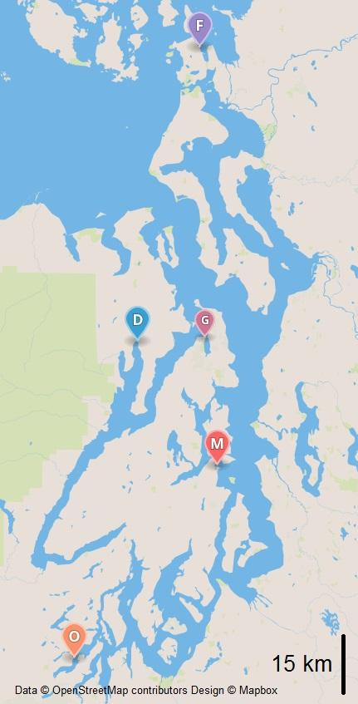

Figure 1. Map of Puget Sound with Broodstock and Outplant Sites. Conditioning site is Port Gamble (G). Broodstock collected from Fidalgo Bay (F), Dabob Bay (D), Oyster Bay (O). Outplanted at Fidalgo Bay (F), Dabob Bay (D), Clam Bay (M), Oyster Bay (O).

|  |  |  |  |
| --- | --- | --- | --- |
| Group / *Site* | *Fidalgo Bay* | *Clam Bay* | *Oyster Bay* |
| Fidalgo Bay | 29.1+/-5.1 | 24.4+/-5.8 | 35.8+/-6.4 |
| Dabob Bay | 24.4+/-4.5 | 21.5+/-4.9 | 28.0+/-5.6 |
| Oyster Bay | 28.9+/-5.1 | 24.0+/-4.9 | 28.0+/-5.2 |

Table 1. Average Size for each group at each site after 13 (Oyster Bay) or 14 (Fidalgo and Clam Bays) months post outplant. Sizes in mm.

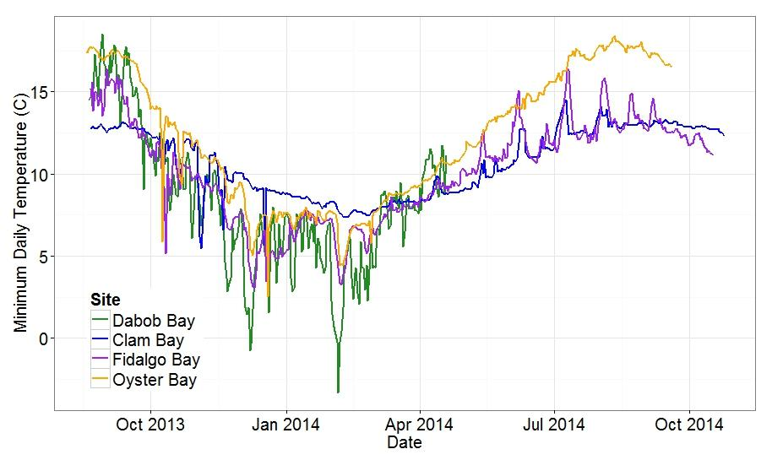

Figure 2. Minimum Observed Daily Temperatures for All Sites. Dabob Bay = Green, Clam Bay = Blue, Fidalgo Bay = Purple, Oyster Bay = Orange

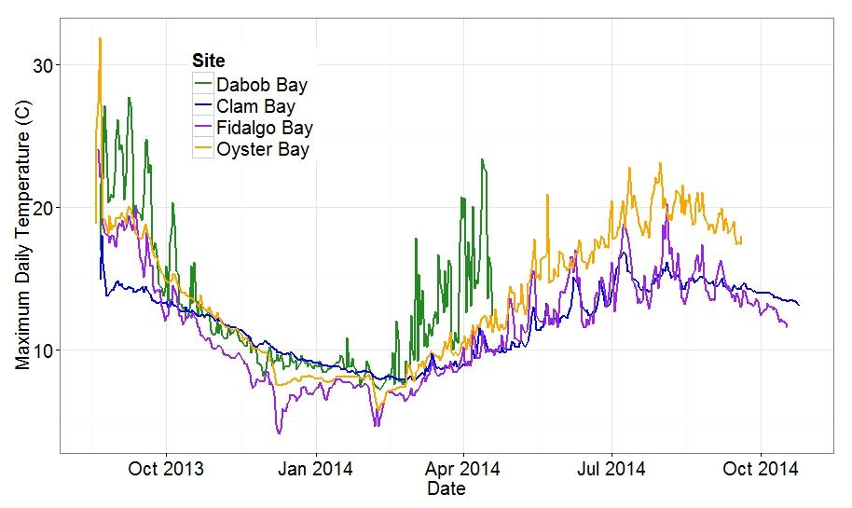Figure 3. Maximum Observed Daily Temperatures for All Sites. Dabob Bay = Green, Clam Bay = Blue, Fidalgo Bay = Purple, Oyster Bay = Orange

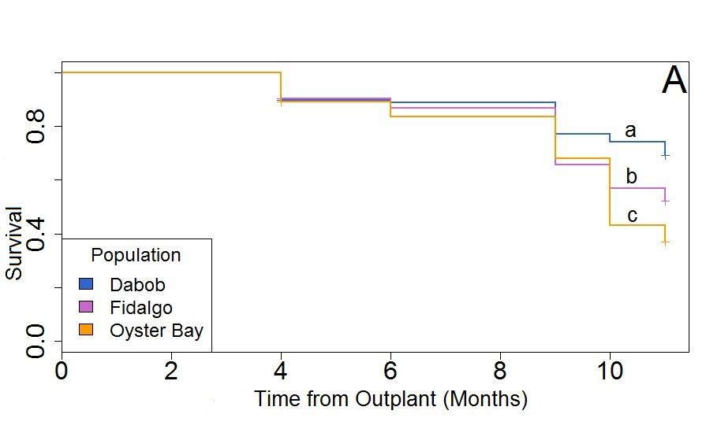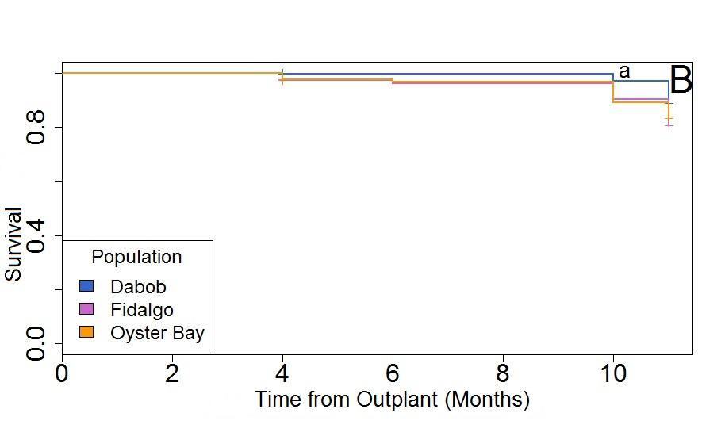

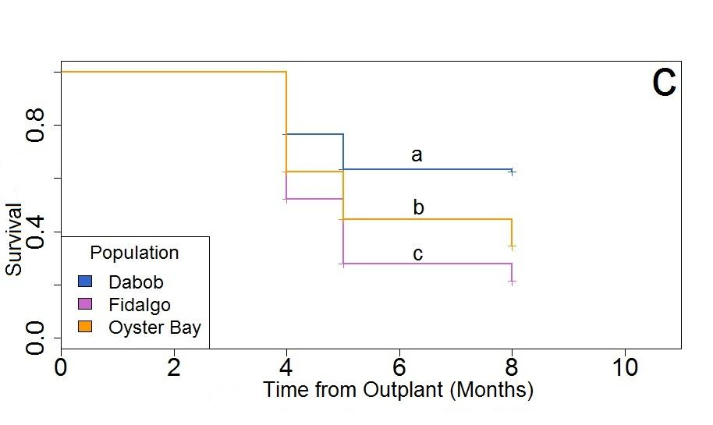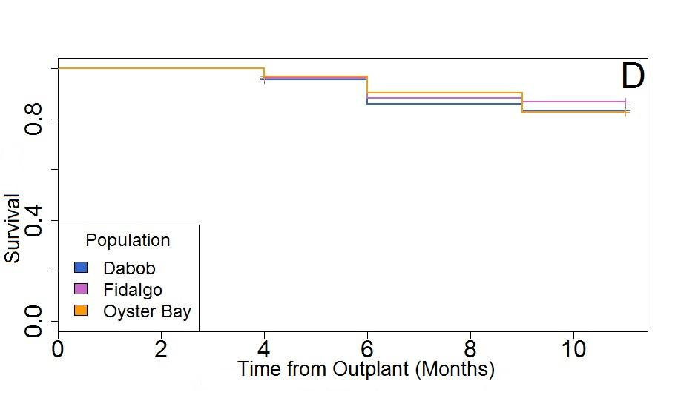

Figure 4. Proportion Survival for Three Oyster Populations. (Dabob Bay = Blue, Fidalgo Bay = purple,. Oyster Bay = orange) at four locations; Oyster Bay (A), Clam Bay (B), Dabob Bay (C), and Fidalgo Bay (D). Lowercase letters(a,b,c) are significant differences.

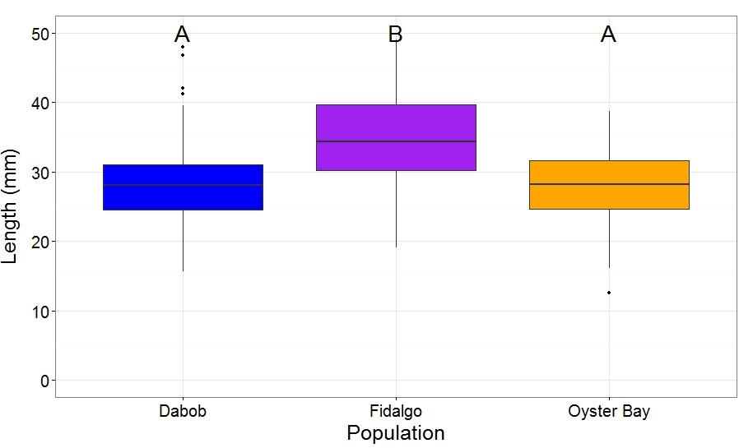

Figure 5. Oyster Size in September 2014 at Oyster Bay. Boxplots with mean size as central line and boxes represent second and third quartile. Horizontal lines are 1st and 4th quartile with dots representing outliers from data set. Letters indicate significant differences.

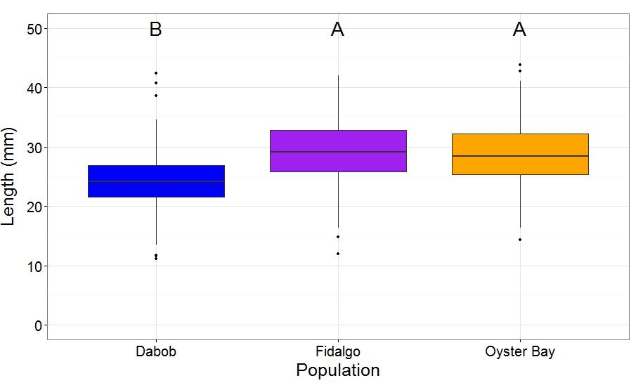Figure 6. Oyster Size in October 2014 at Fidalgo Bay. Boxplots with mean size as central line and boxes represent second and third quartile. Horizontal lines are 1st and 4th quartile with dots representing outliers from data set. Letters indicate significant differences.

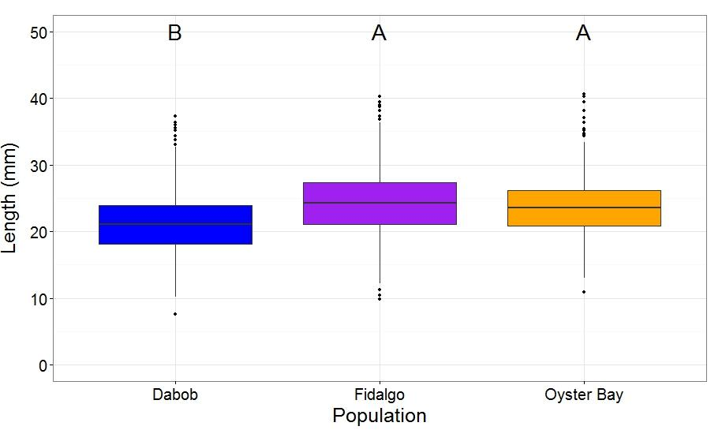

Figure 7. Oyster Size in October 2014 at Clam Bay. Boxplots with mean size as central line and boxes represent second and third quartile. Horizontal lines are 1st and 4th quartile with dots representing outliers from data set. Letters indicate significant differences.

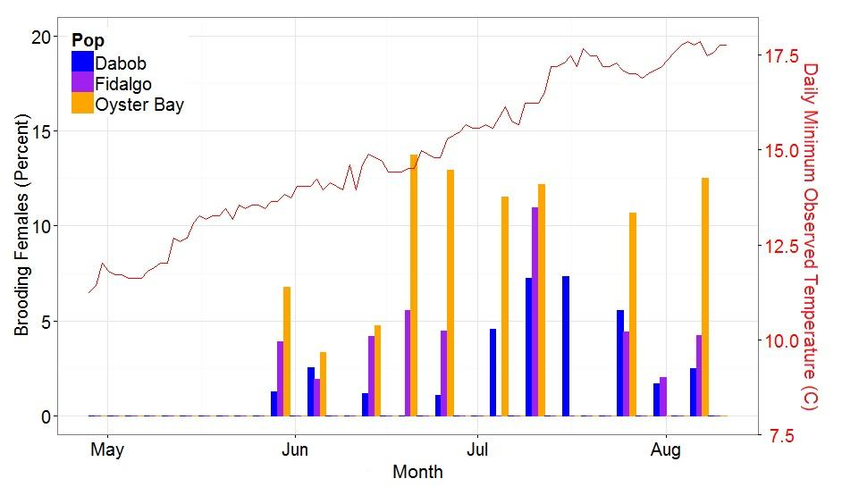

Figure 8. Percent Brooding Females from Each Population at Each Sample Date at Oyster Bay. Percent determined by number of brooding females (Br) divided by number of open oysters (T) or %=(Br/T)*100. Blue = Dabob Bay, Purple = Fidalgo Bay, Orange = Oyster Bay.

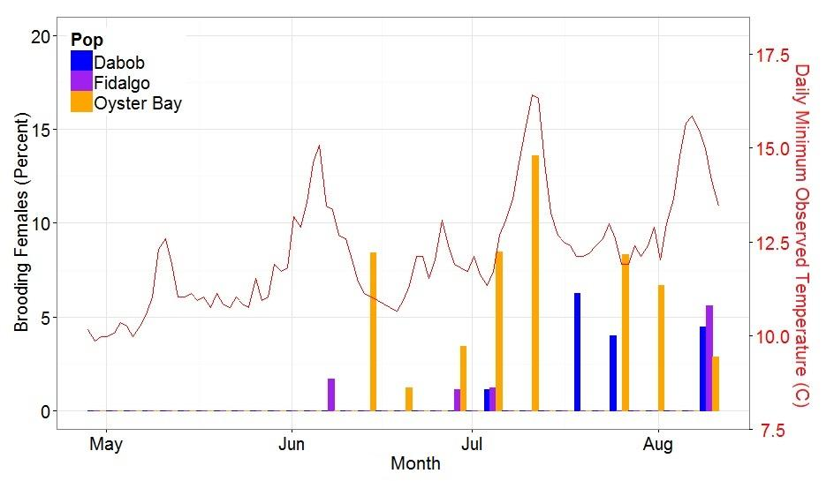

Figure 9. Percent Brooding Females from Each Population at Each Sample Date at Fidalgo Bay. Percent determined by number of brooding females (Br) divided by number of open oysters (T) or %=(Br/T)*100. Blue = Dabob Bay, Purple = Fidalgo Bay, Orange = Oyster Bay.

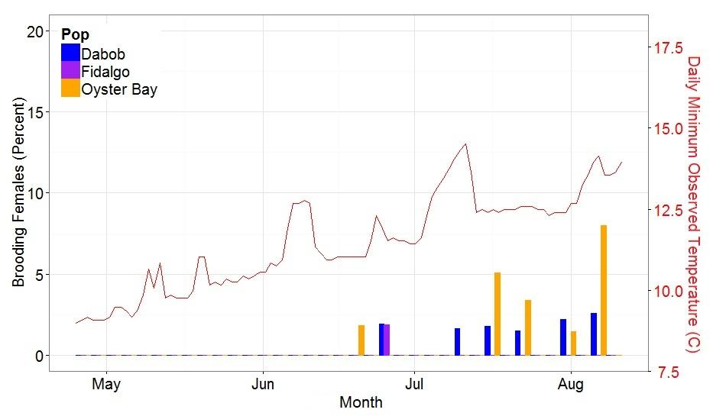

Figure 10. Percent Brooding Females from Each Population at Each Sample Date at Clam Bay. Percent determined by number of brooding females (Br) divided by number of open oysters (T) or %=(Br/T)*100. Blue = Dabob Bay, Purple = Fidalgo Bay, Orange = Oyster Bay.